Assignment 4

Q1. Maximum Likelihood Estimation with Features

Step 1: Understanding and Plotting the Data
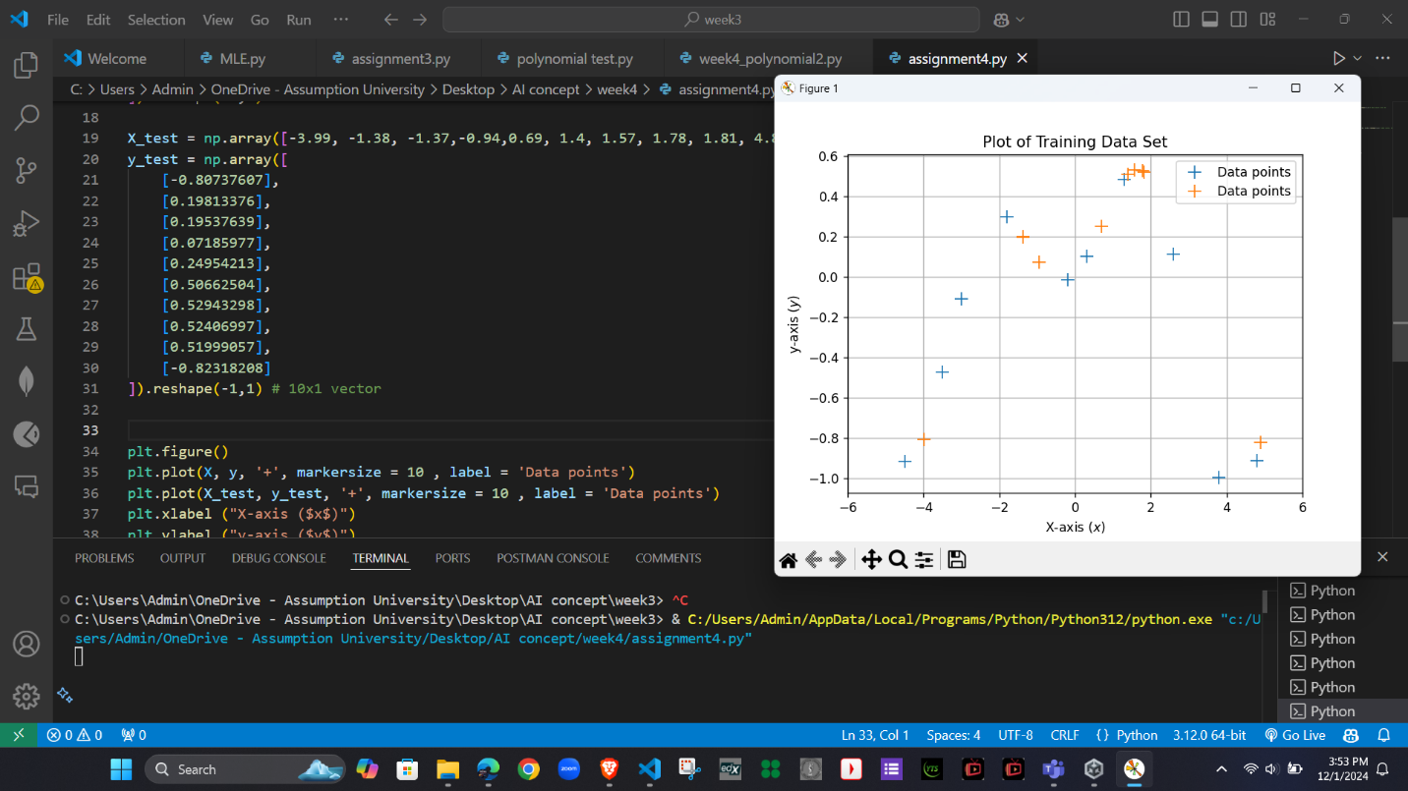

Step 2: Polynomial Feature Transformation
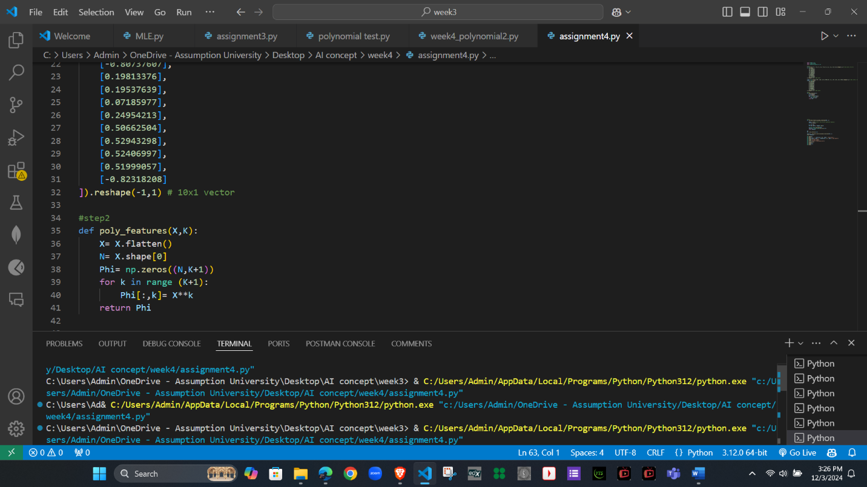
The purpose and the effect of this transformation:
Polynomial transformation enables linear models to fit nonlinear data by adding higher-degree features. It improves flexibility but risks underfitting with low degrees or overfitting with high degrees. The right degree balances accuracy and complexity for better generalization.

Step 3: Fitting the Model Using Maximum Likelihood
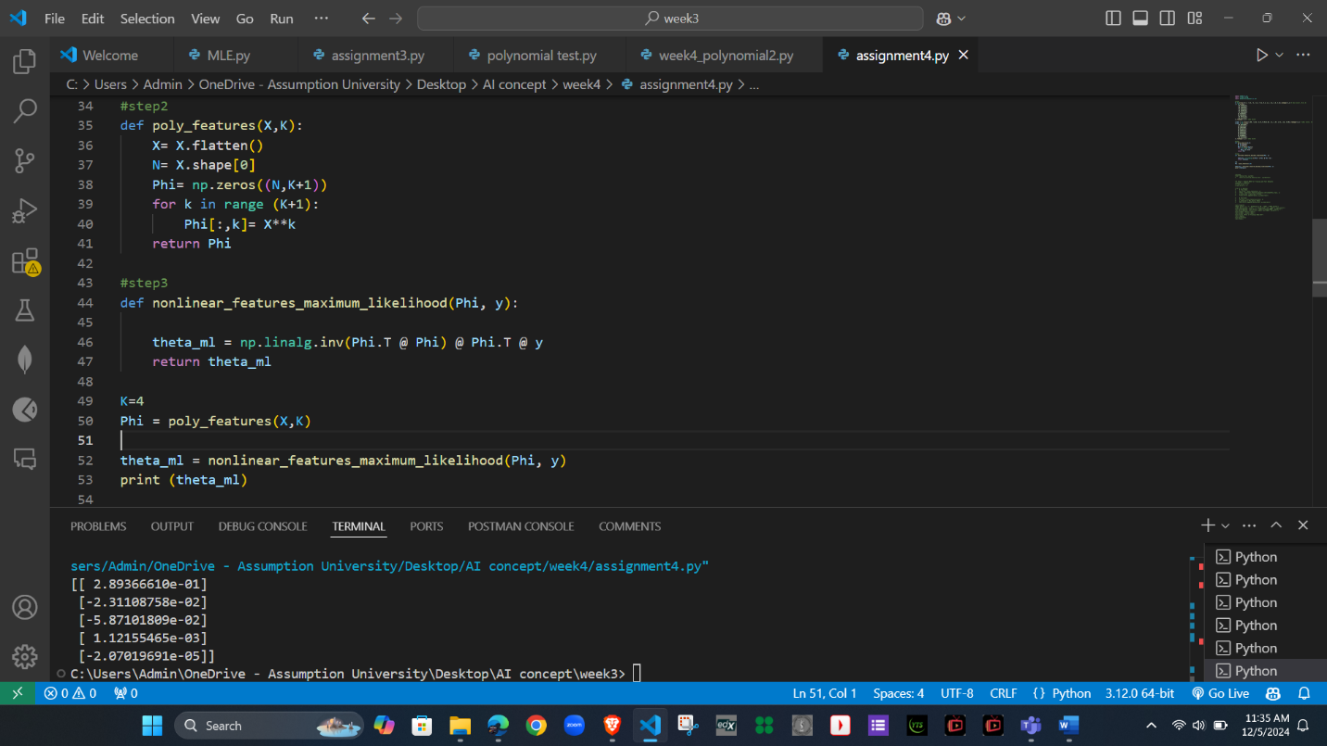

Step 4: Model Evaluation Using RMSE
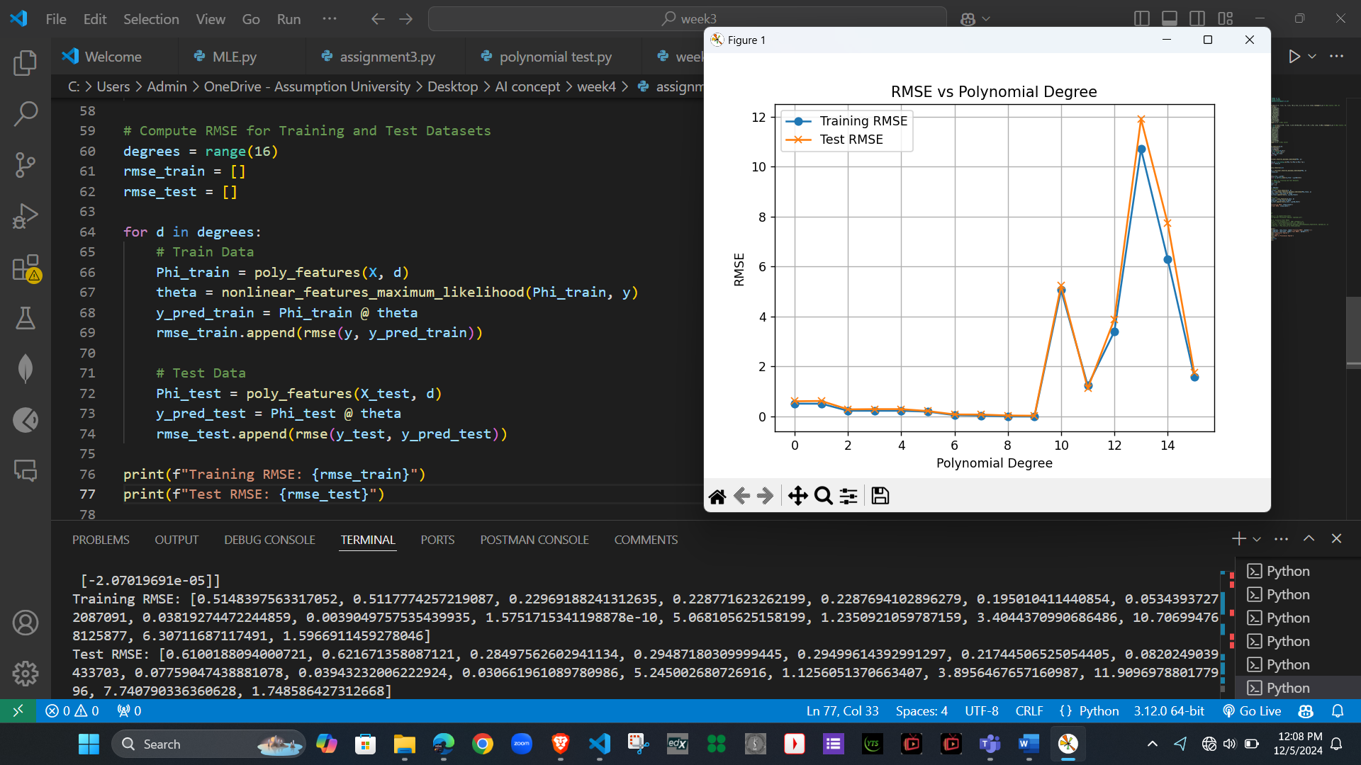

Step 5: Selecting the Best Model
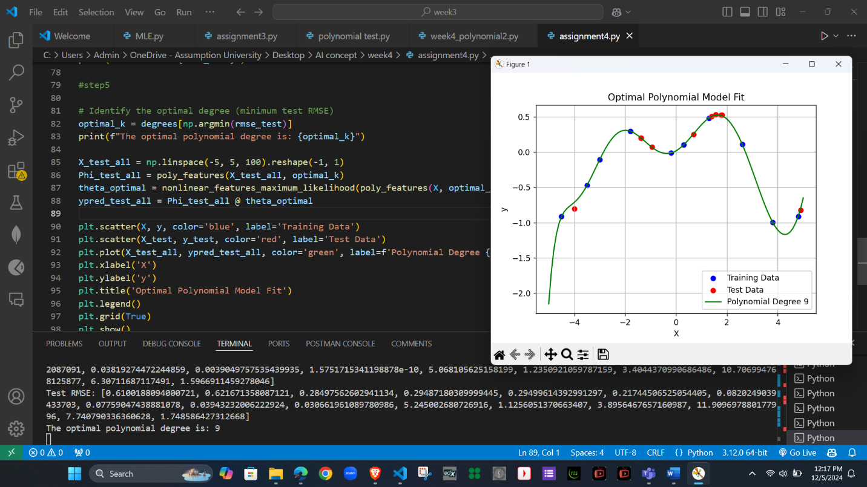
Why was this degree optimal?
- The optimal degree minimizes the RMSE for the test dataset, striking a balance between underfitting (too simple) and overfitting (too complex).
- Degrees that are too low (e.g., 0 or 1) underfit, being too simple and cannot catch the small details in the data, so they don’t fit well.
- Degrees that are too high (e.g., >10) overfit, capturing noise rather than the true relationship.
Model Complexity and Overfitting/Underfitting:
- Lower degrees: Underfitting, as the model cannot capture complex patterns.
- Higher degrees: Overfitting, as the model tries to fit every data point, including noise.
- Optimal degree: Provides the best generalization for unseen data (test set).
Step 6: Conclusion
Summary of Findings:
- The polynomial regression model's performance depends heavily on the degree of the polynomial.
- Low-degree models (e.g., 0 or 1): These models were too simple and underfit the data, missing important patterns and resulting in high training and test RMSE.
- High-degree models (e.g., >10): These models overfit the training data, capturing noise instead of meaningful trends, which led to high test RMSE.
- The optimal degree was the one that minimized test RMSE, achieving a balance between underfitting and overfitting.

Trade-offs Between Model Complexity and Prediction Accuracy:
- Low Complexity (Low Degree):
  - Advantages: Simple, easier to interpret, and less likely to overfit.
  - Disadvantages: Poor performance if the relationship between variables is complex (underfitting).
- High Complexity (High Degree):
  - Advantages: Can model complex relationships in the data and fit the training data very well.
  - Disadvantages: Risk of overfitting, where the model captures noise instead of general patterns, leading to poor test performance.
- Balanced Complexity (Optimal Degree):
  - The optimal degree balances the trade-off, capturing the true patterns in the data without fitting the noise, resulting in better generalization to unseen data.

Q2. K-means

Step 1: Prepare Dataset
  - Clean the unnecessary data, duplicate data and missing value
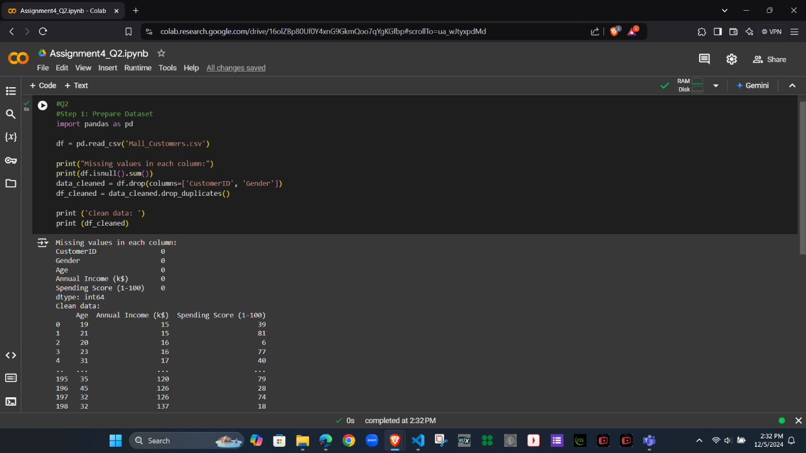

Step 2: Visualize Data Before Clustering

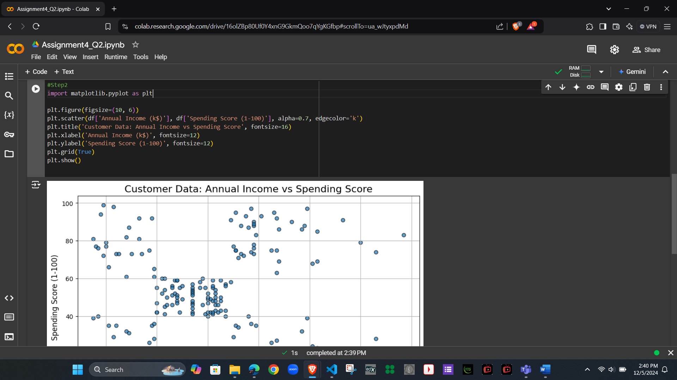

Step 3: Implement K-means Clustering and Determine Optimal Clusters
  - Code for step3 using Elbow Method Code
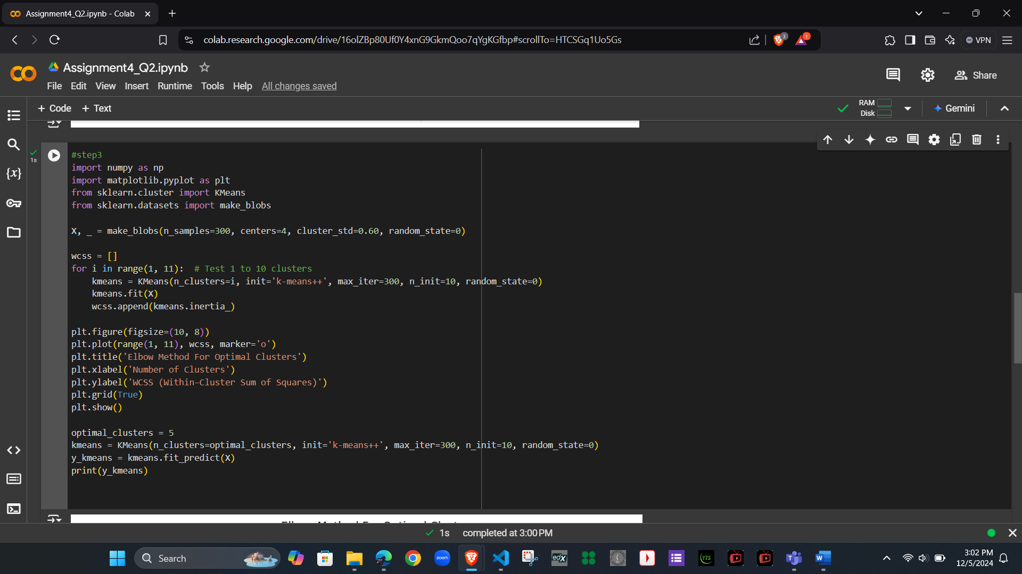

  - Plot the Elbow Method Graph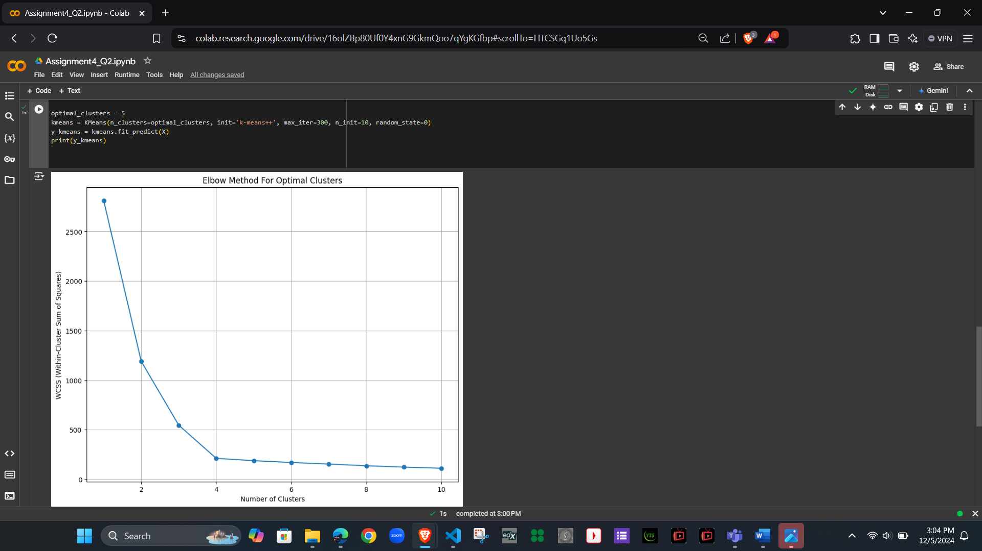

  - K-mean output
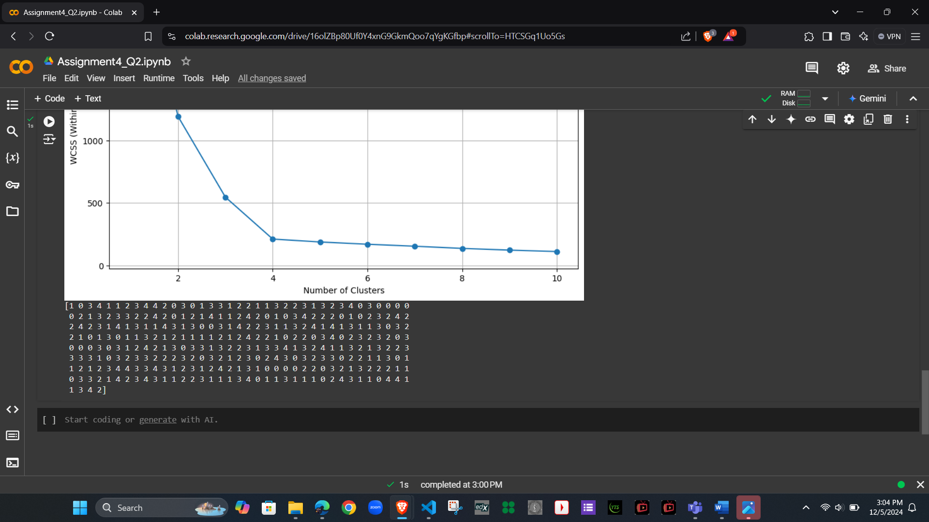

Step 4: Visualize Data After Clustering
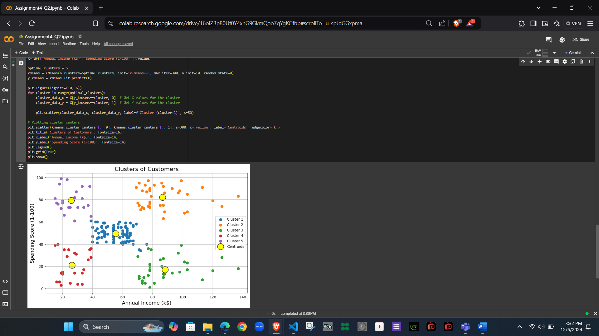

Step 5: Interpret Your Results
The clustering results provide insights into customer segmentation based on Annual Income (k$) and Spending Score (1-100). Here’s a detailed breakdown of each cluster:
Cluster Sizes:
- Cluster 0 (81 customers): Largest group with moderate income and spending behavior.
- Cluster 1 (39 customers): High-income, high-spending customers (premium segment).
- Cluster 2 (35 customers): High-income, low-spending customers (potential for engagement).
- Cluster 3 (23 customers): Low-income, low-spending customers (limited purchasing power).
- Cluster 4 (22 customers): Low-income, high-spending customers (price-sensitive but engaged).
Cluster Statistics Analysis:
- Cluster 0 (Moderate Income, Moderate Spending):
  - Average Annual Income: ~$55.3k
  - Average Spending Score: ~49.5
  - Represents customers with balanced spending habits, likely mid-tier or average-value customers.
  - Opportunity: Maintain their satisfaction with general promotions or loyalty programs.
- Cluster 1 (High Income, High Spending):
  - Average Annual Income: ~$86.5k
  - Average Spending Score: ~82.1
  - High-value customers who spend a lot and likely purchase premium products/services.
  - Opportunity: Strengthen loyalty through exclusive rewards, VIP programs, and personalized experiences.
- Cluster 2 (High Income, Low Spending):
  - Average Annual Income: ~$88.2k
  - Average Spending Score: ~17.1
  - High-income customers with low engagement or spending behavior.
  - Opportunity: Explore why these customers are not spending much (e.g., mismatched offerings, lack of interest). Use targeted marketing to improve engagement.
- Cluster 3 (Low Income, Low Spending):
  - Average Annual Income: ~$26.3k
  - Average Spending Score: ~20.9
  - Budget-conscious customers with low purchasing power.
  - Opportunity: Offer affordable options, discounts, or budget-friendly product lines to attract and retain these customers.
- Cluster 4 (Low Income, High Spending):
  - Average Annual Income: ~$25.7k
  - Average Spending Score: ~79.4
  - Price-sensitive customers who are highly engaged despite having limited income.
  - Opportunity: Provide value-based products and loyalty programs to encourage frequent purchases.

How This Information Helps Identify Specific Groups:
- Targeted Marketing Strategies:
  - Cluster 1: Focus on retaining high-value customers through personalized and exclusive offers.
  - Cluster 2: Design campaigns to convert high-income, low-spending customers into active spenders.
  - Cluster 4: Develop affordable product bundles or discounts to maximize the engagement of price-sensitive customers.
- Customer Retention:
  - Enhance customer retention in Cluster 0 through loyalty programs that reward consistent spending.
  - Identify disengagement reasons in Cluster 2 and address them with surveys or tailored incentives.
- Product and Service Design:
  - Offer premium products and services to Cluster 1.
  - Introduce budget-friendly options for Cluster 3 and Cluster 4.
- Resource Allocation:
  - Allocate more resources to engage and retain high-potential customers in Clusters 1, 2, and 4.
  - Focus less on Cluster 3, as they represent a low-spending group with limited income.
- Long-Term Strategies:
  - Monitor spending trends in Cluster 2 to identify signs of increased engagement.
  - Encourage upselling and cross-selling to moderate spenders in Cluster 0.
Additional code
